**A7Wb Want to learn more - Comparing two population variances (Variance Ratio test F-test and Levene’s test)**

Contents

Testing for homogeneity of variance (Hartley and Levene tests) 1

Method 1: Hartley’s method 1

Method 2: Levene’s test for comparing population variances 3

Excel solutions 7

SPSS solution 11

Check your understanding 12

# Testing for homogeneity of variance (Hartley and Levene tests)

In order to use a parametric statistical test, your data should show homogeneity of variance: in other words, the spread of scores in each condition should be roughly similar. (The spread of scores is reflected in the variance, which is simply the standard deviation squared). Sometimes, it's obvious that the variances are very dissimilar; you just need to look at them. In other cases, it's less obvious, and a more formal test is required. There are various ways to test for homogeneity of variance. In this section we will explore two statistical tests to assess for homogeneity of variance:

1. Hartley’s Fmax test.
2. Levene’s test.

If you are performing the statistical tests by hand or by using Excel, then it's easier to use Hartley's Fmax test than Levene's test. Both the Hartley and Levene tests can be solved using Excel but SPSS will automatically provide Leven’s test results when conducting a two-sample independent t-test.

## Method 1: Hartley’s method

In the previous sections, we introduced the concept of hypothesis testing to test the difference between interval level variables using both z and t tests. In Example 6.10 we assumed that the population variances were equal for both populations (Shop A and B) and conducted a pooled two sample t test. Conduct a F test for two population variances (variance ratio test to test this hypothesis. The test assumptions are as follows:

1. Simple random sampling.
2. The two populations are independent of each other.
3. Both populations are normally distributed – this test sensitive to this assumption.

If σ12 and σ22 are the population variances that we would like to compare, then we can create a hypothesis test to test the null hypothesis:

Null hypothesis H0: σ12 = σ22

With alternative hypotheses:

H1: σ12 < σ22 Lower one tail test

H1: σ12 > σ22 Upper one tail test

H1: σ12 ≠ σ22 Two tail test

Consider the null hypothesis and the upper one tail alternative hypothesis statement. If we divide by σ22 then H0 and H1 statements can be written as follows

H0:

H1:

To test this, we would take two samples with s12 the variance of a random sample of n1 observations from the population with variance σ12 and s22 the variance of a random sample of n2 observations from the population with variance σ22. To decide how large s12/s22 should be before we must reject H0, we need to define the sampling distribution for s12/s22.

It can be shown that for two normally distributed populations with equal variances (σ12 = σ22) then the test statistic s12/s22 has an **F-distribution** with dfnumerator = n1 - 1 and dfdenominator = df2 – 1 degrees of freedom if the null hypothesis of equality of variance is true.

${\text{F}}_{\text{cal}}\text{= }\frac{\text{Largest sample variance}}{\text{smallest sample variance}}$ (1)

dfnumerator = sample size of the largest sample variance - 1 (2)

dfdenominator = sample size of the smallest sample variance - 1 (3)

The sampling distribution of the test statistic F = s12/s22 is illustrated in Figure 6.47.

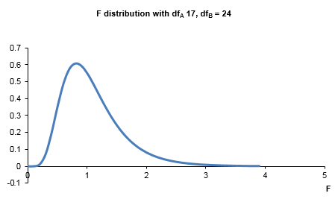

Figure 1 F distribution

Properties:

1. F distribution is not symmetric.
2. Values of the F distribution cannot be negative.
3. The exact shape of this curve depends upon the numerator degrees (dfA) and denominator degrees of freedom (dfB), where dfA = nA – 1 and dfB = nB – 1.

## Method 2: Levene’s test for comparing population variances

In statistics, Levene's test is an inferential statistic used to assess the equality of variances for a variable calculated for two or more groups. Some common statistical procedures assume that variances of the populations from which different samples are drawn are equal. Levene's test assesses this assumption of homogeneity of variance.

It tests the null hypothesis that the population variances are equal (called homogeneity of variance or homoscedasticity). If the resulting p-value of Levene's test is less than some significance level (typically 0.05), the obtained differences in sample variances are unlikely to have occurred based on random sampling from a population with equal variances. Thus, the null hypothesis of equal variances is rejected, and it is concluded that there is a difference between the variances in the population. The test statistic, W, is defined as follows:

$W= \frac{\left(N-k\right)}{\left(k-1\right)}\frac{\sum_{i=1}^{k}{N_{i}}{\left(Z_{i.}-Z_{..}\right)}^{2}}{\sum_{i=1}^{k}{\sum_{j=1}^{Ni}{{\left(Z_{ij}-Z_{i.}\right)}^{2}}}}$ (4)

Where

k = the number of different groups to which the sampled cases belong

Ni = the number of cases in the ith group

N = the total number of cases in all groups

yij = the value of the measured variable for the jth case from the ith group

$$Z_{ij}= \left\{\begin{aligned}\left|Y_{ij}-{\overline{Y}}_{i.}\right|, {\overline{Y}}_{i.} is a mean of the i-th group \\ \left|Y_{ij}-{\overline{Y}}_{i.}\right|, {\overline{Y}}_{i.} is the median of the i-th group\end{aligned}\right.$$

Definitions:

1. Levene’s test – uses the mean value.
2. Modified Levene’s test – called the Brown-Forsythe test – uses the median value.

$$Z_{i.}=\frac{1}{N_{i}}\sum_{j=1}^{N_{i}}{Z_{ij} is the mean of the Z_{ij} for group i}$$

$$Z_{..}=\frac{1}{N}\sum_{i=1}^{k}{\sum_{j=1}^{N_{i}}{Z_{ij} is the mean of all Z_{ij}}}$$

Levene’s test for equality of variance assumptions:

1. Simple random sampling.
2. The samples from the populations under consideration are independent.
3. The test does not assume that all populations are normally distributed and is recommended when the normality assumption is not viable.

The test statistic W is approximately F-distributed with k − 1 and N − k degrees of freedom, and hence is the significance of the outcome w of W tested against F (α, k − 1, N − k), and α = the chosen level of significance (usually 0.05 or 0.01).



**Example**

In this example, we will use the **F test for equality of population variance** to check if the two population variances in Example 6.8 can be considered equal with a 95% confidence.

Hartley’s solution

The five-step procedure to conduct this test progresses as follows.

**Step 1 - State hypothesis**

The alternative hypothesis statement implies that the population variances are not equal. The null and alternative hypotheses would be stated as follows:

Null hypothesis H0: 

Alternative Hypothesis H1: 

The ≠ sign implies a two-tail test (or non-**directional test**).

**Step 2 - Select test**

We now need to choose an appropriate statistical test for testing H0. From the information provided we note:

* Number of samples - two samples.
* The statistic we are testing - testing that the variances are different from each other.
* Size of both samples small (nA = 18 and nB = 25).
* Nature of population from which sample drawn – normally distributed.

In this case conduct an F test for variance.

**Step 3 - Set the level of significance**  = 0.05

For two-tail (non-directional) tests use α = significance level/2 = 0.025.

**Step 4 - Extract relevant statistic**

nA = 18

nB = 25

sA = 44.23

sB = 66.94

Therefore, given largest variance = sample B variance = 66.94, smallest variance = sample A variance = 44.23, then from equation (6.24) the value of F is



With from equations (6.25) and (6.26):

dfnumerator = sample size of the largest sample variance – 1 = nB – 1 = 25 – 1 = 24

dfdenominator = sample size of the smallest sample variance - 1 = nA – 1 = 18-1 = 17

**Step 5 - Make a decision**

The calculated test statistic Fcal = 2.29. Calculate the critical test statistic, Fcri. In the example H1: . The critical F values can be found from statistical tables:

Upper critical value FU

We only need to look at the upper critical value given F > 1 (we always have the largest variance/smallest variance).

We have two tails such that each tail area = 0.05/2 = 0.025

df numerator = dfB = 24

df denominator = dfA = 17

From statistical tables:

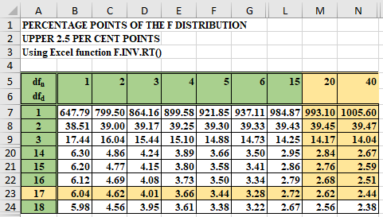

Figure 2

The critical F value for dfnumerator = 24 and dfdenominator = 17 =can be found from statistical tables for an upper critical area of 0.025 as illustrated in Figure 2.

To find F24,17 we will need to use linear interpolation given we know the critical F value for when dfnumerator = 20 and 40 where dfdenominator is fixed at 17.

$$F_{24, 17}= F_{20,17}- \frac{\left(F_{40,17}- F_{20,17}\right)}{\left({df}_{24}- {df}_{20}\right)}$$

$$F_{24, 17}= 2.62- \frac{\left(2.62- 2.44\right)}{\left(24- 20\right)}$$

$$F_{24, 17}=2.575$$

Therefore, upper critical value FU = +2.58

Note, we are only interested in FU given that F > 1. The lower critical value can be calculated using equation ((6.28).

FL = 1/FU (6.28)

FL = 1/2.56

FL = 0.39

Does the test statistic lie within the region of rejection? Compare the calculated and critical F values to determine which hypothesis statement (H0 or H1) to accept. Figure 3 illustrates the relationship between the p-value, F test statistic, and the critical F statistic calculated using Excel.

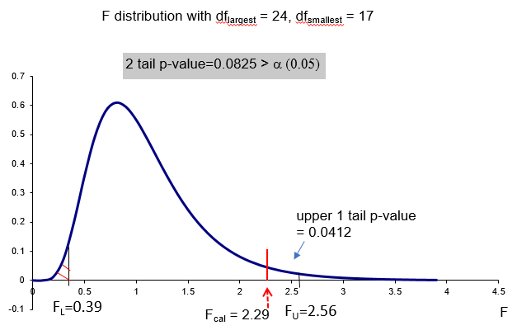

Figure 3 F distribution solution for Example 6.9

Given that the Fcal (2.29) lies between the lower critical value (FL) and upper critical value (FU), we will fail to reject H0 and reject H1.

We conclude that based upon the sample data collected that we have evidence that the population variances are not significantly different at the 95% level of confidence. In this case, we would be reasonably happy to conduct the 2-sample pooled t test.

Table 1 illustrates the alternative one tail hypothesis tests.

|  |  |
| --- | --- |
| Hypothesis - upper one tail test | Hypothesis - lower one tail test |
| Null hypothesis H0:  Alternative hypothesis H1:  With α = significance level | Null hypothesis H0:  Alternative Hypothesis H1:  With α = significance level |

Table 1

The upper (FU) and lower (FL) critical values for a one tail test can be calculated using Excel as follows:

1. Upper one tail F value = FU =F.INV.RT(significance level, df for largest variance, df for smallest variance).
2. Lower one tail F value = FL =F.INV(significance level, df for smallest variance, df for largest variance).

## Excel solutions

Figure 4 illustrates the Excel solution.

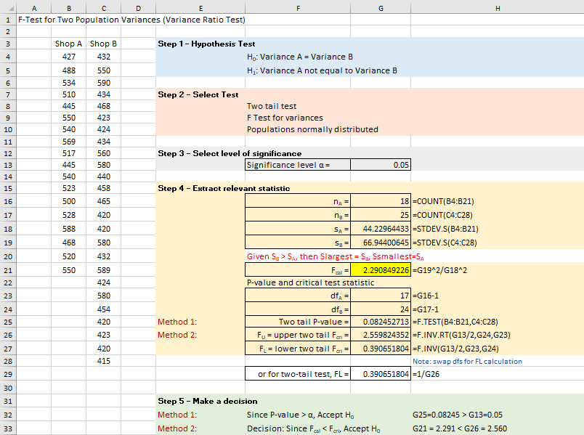

Figure 4 Excel solution for Example 6.9

**Excel solution**

A: Cells B4:B21 Values

B: Cells C4:C28 Values

Significance level Cell G13 Value

nA = Cell G16 Formula: =COUNT(B4:B21)

nB = Cell G17 Formula: =COUNT(C4:C28)

sA = Cell G18 Formula: =STDEV.S(B4:B21)

sB = Cell G19 Formula: =STDEV.S(C4:C28)

Fcal = Cell G21 Formula: =G19^2/G18^2

df for smallest variance dfA = Cell G23 Formula: =G16-1

df for largest variance dfB = Cell G24 Formula: =G17-1

Two tail p-value = Cell G25 Formula: =2*F.DIST.RT(G21,G23,G24)

FU = upper two tail Fcri = Cell G26 Formula: =F.INV.RT(G13/2, G24, G23)

FL = lower two tail Fcri = Cell G27 Formula: =F.INV(G13/2, G23, G24)

or if two tail test, FL = Cell G29 Formula: =1/G26

Alternatively, you could use the F.Test Excel function which is a two-tail test =F.TEST(B4:B21,C4:C28) = 0.082452713.

From Excel:

* Calculated F test statistic, Fcal = 2.29 < critical F test statistic Fcri = 2.56, accept the null hypothesis.
* Two-tail p-value = 0.082 > 0.05, accept the null hypothesis.

For a one tail test then use the following formulas

|  |  |  |
| --- | --- | --- |
| Lower 1-tail p-value = | 0.041226356 | =FDIST(G21,G24,G23) |
| Lower 1-tail critical F = | 0.483025528 | =FINV(1-G13,G24,G23) |
| Upper 1-tail p-value = | 0.041226356 | =F.DIST.RT(G21,G24,G23) |
| Upper 1-tail critical F = | 2.189766456 | =F.INV.RT(G13,G24,G23) |

Table 2

Excel Data Analysis Ad-In solution for a two-sample t test for the mean

Alternatively, we can use the F – Test Two Sample for Variance Data Analysis tool.

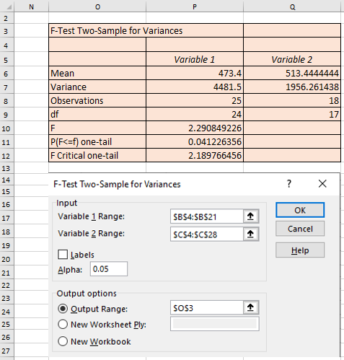

Figure 5 Excel data analysis solution for Example 6.9

This tool only performs a one-tail test, the one-tail p-value = 0.041226356 needs to be doubled to provide the two-tail p-value = 0.082452713.

Levene’s Excel solution

Figures 6 and 7 illustrate the implementation of Leven’s test in Excel

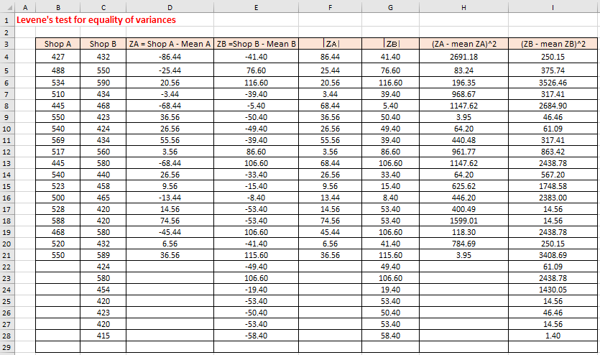

Figure 6

**Excel solution**

Shop A Cells B4:B21 Values

Shop B Cells C4:C28 Values

ZA Cell E4 Formula: =B4-$M$20

Copy formula down from D4:D21

ZB Cell E4 Formula: =C4-$M$21

Copy formula down from E4:E28

⏐ZA⏐ Cell F4 Formula: =ABS(D4)

Copy formula down from F4:F21

⏐ZB⏐ Cell G4 Formula: =ABS(E4)

Copy formula down from G4:G28

(ZA – mean ZA)^2 Cell H4 Formula: =(F4-$M$22)^2

Copy formula down from H4:H21

(ZB – mean ZB)^2 Cell I4 Formula: =(G4-$M$23)^2

Copy formula down from I4:I28

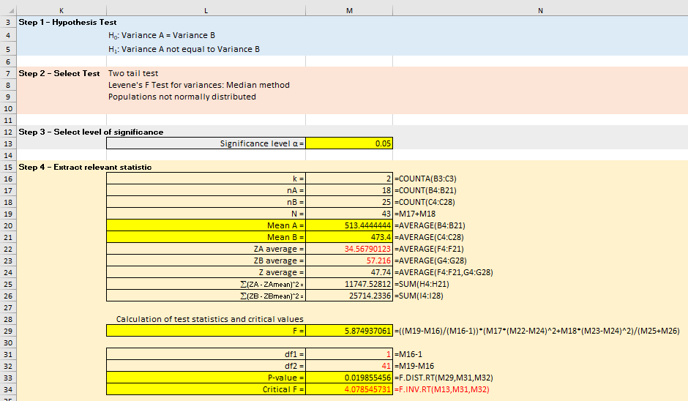Figure 7

**Excel solution**

Significance level α = Cell M13 Value

k = Cell M16 Formula:=COUNTA(B3:C3)

nA = Cell M17 Formula:=COUNT(B4:B21)

nB = Cell M18 Formula:=COUNT(C4:C28)

N = Cell M19 Formula:=M17+M18

Mean A = Cell M20 Formula:=AVERAGE(B4:B21)

Mean B = Cell M21 Formula:=AVERAGE(C4:C28)

ZA average = Cell M22 Formula:=AVERAGE(F4:F21)

ZB average = Cell M23 Formula:=AVERAGE(G4:G28)

Z average = Cell M24 Formula:=AVERAGE(F4:F21,G4:G28)

å(ZA - ZAmean)^2 = Cell M25 Formula:=SUM(H4:H21)

å(ZB - ZBmean)^2 = Cell M26 Formula:=SUM(I4:I28)

F = Cell M29

Formula:=((M19-M16)/(M16-1))*(M17*(M22-M24)^2+M18*(M23-M24)^2)/(M25+M26)

df1 = Cell M31 Formula:=M16-1

df2 = Cell M32 Formula:=M19-M16

P-value = Cell M33 Formula:=F.DIST.RT(M29,M31,M32)

Critical F = Cell M34 Formula:=F.INV.RT(M13,M31,M32)

From Excel: F = 5.875, P-value = 0.0198. If you use SPSS to undertake the test on this data then you will find the same results are reproduced. Given 0.02 < 0.05, reject H0 and accept H1. Evidence suggests at a 5% significance level that the two population variances are significantly different.

If you replace the mean with the median in Cells M20 and M21 you will have conducted the modified Levene’s test – called the Brown-Forsythe test.

Excel Data Analysis solution for Levene’s test

Or use a One sample ANOVA test on ⎮ZA⎮ and ⎮ZB⎮ columns: Data > Data Analysis > Anova: Single Factor. Figure 8 illustrates the Excel solution

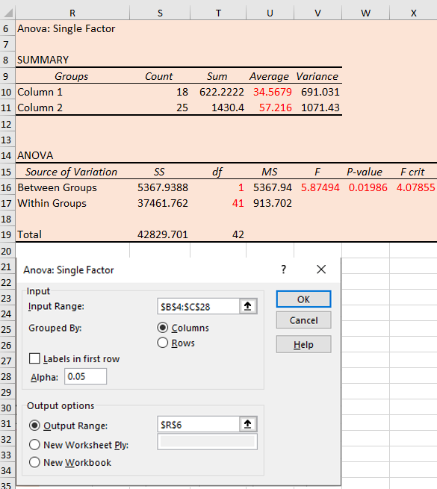

Figure 8

From Excel, F = 5.87, Fcri = 4.08, and p-value = 0.01986. Therefore, given Fcal > Fri (or p-value < significance level), accept the alternative hypothesis. Evidence suggests at a 5% significance level that the two population variances are significantly different.

## SPSS solution

The F-test we have used so far uses the sample standard deviations to measure whether the population variances are not equal. The sample standard deviations are very sensitive to the two population distributions being non-normal. SPSS uses Levene’s test for **homogeneity of variance** (equal variance) which is a non-parametric test to assess if the two population variances are equal. This test does not assume normality while still assuming independence. The Excel solution for Levene’s non-parametric test is available on the online resource site for the textbook.

Figure 9 illustrates the SPSS solution with Levene’s F-test result of F = 5.875 with a corresponding p-value = 0.020. This value is smaller than the test significance level (0.05), conclude we have evidence that the two population variances are not equal. From the Excel solution, we have F = 2.29 and a one tail p-value = 0.041226 or a two-tail p-value = 2*0.041226 = 0.0825. Given 0.0825 > 0.05, accept H0, and conclude we have no evidence that the two population variances are not equal. Remember if the two populations are not normally distributed then you should not use this test.

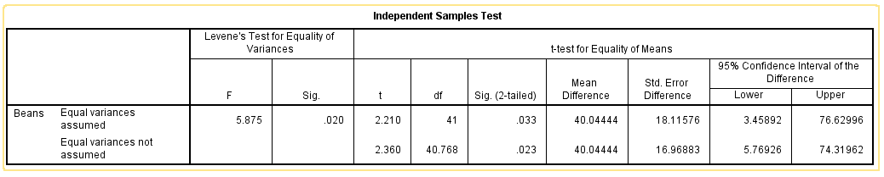

Figure 9

## Check your understanding

X1 In check your understanding X6.25 we assumed that the two population variances are equal. Conduct an appropriate test to check if the variances are equal (test at 5% and 1%).

X2 In check your understanding X6.26 we assumed that the two population variances are equal. Conduct an appropriate test to check if the variances are equal (test at 5%)?